数字媒体技术专业
《Web服务技术》课程实训报告

实验名称： | 实训2 基于jQM+php+mysql的  移动端同学管理系统
时 间： | 2019.11.01
地 点： | 教学楼1-216
班 级： | 17新媒体
姓 名：
学 号： | 17
指导教师： | 杜兆将

实训2基于jQM+php+mysql的移动端同学管理系统
1. 实训要求
- 后台数据库:MySQL、数据表---同学表(学号、姓名、性别、生日、手机号、QQ号、EMail、家庭住址、照片)，用户表(用户名、密码)。
- Web端：编程语言php、实现同学表的增删改查和登录。
- 手机端：基于Html5、Css3、jQuery、jQueryMobile等(或其他移动UI框架)技术实现：登录页面(用户名、密码)、主界面(含菜单、logo、版权)、浏览页面(姓名、手机号、，，，)、增删改同学、拨打同学电话、发送EMail、发短信。
- 前后端数据交流采用ajax+json技术，密码传送、保存采用md5技术。
- 增删改同学信息要求客户端h5验证输入数据、数据库端SQL存储约束验证数据。
- 文件名、数据库名、表名种要有设计者姓名字母缩写，字段名用中文。
- 项目要部署在阿里centos云上、数据库要部署在阿里MySql云端，要在手机端上网浏览，运行界面要美观、整洁。
- 软件版本：jQery 1.11.3、jQuery Mobile 1.45、php 7.3.10、MySql 5.7.23
2. 实训原理
jQuery。 每个知识点写上2-5行解释
jQuery Moblie。
Php。
Php pdo。
MySql。
Ajax Jsonl。
。
3. 实训过程
3.1 数据库
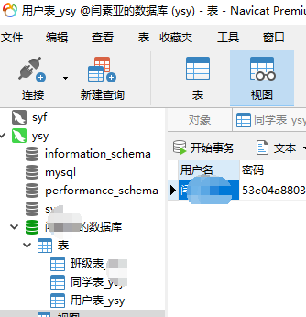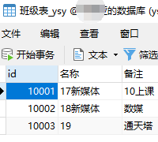
图1 用户表 图2 班级表

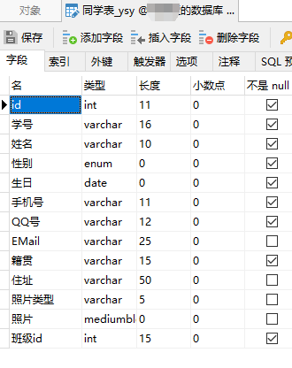
图3 同学表字段

--1. 创建数据库
在Navicat中创建“XXX的数据库”，字符集设为utf8、排序规则设utf8_general_ci

--2. 创建用户并授权
grant all on `...的库`.* to WBd@'%' identified by 'mm....>';
或
CREATE USER `你的用户名`@`%` IDENTIFIED BY '你的密码';
GRANT all ON `XXX的数据库`.* TO `用户`@`%`;

2.1 登录MySQL
mysql -u root -p
2.2 添加新用户（允许所有ip访问）
create user 'test'@'*' identified by '123456';（test:用户名，*：所有ip地址，123456：密码）
2.3 创建数据库
create database testdb;
2.4 为新用户分配权限
grant all on `testdb`.* to 'test'@'%' identified by '123456';
2.5 刷新权限
flush privileges;

-3. 创建班级表，同学表，用户表
--同班级表：
CREATE TABLE `班级表_xxx` (
`id` int(11) NOT NULL AUTO_INCREMENT,
`名称` varchar(50) CHARACTER SET utf8 COLLATE utf8_general_ci NOT NULL,
`备注` varchar(100) CHARACTER SET utf8 COLLATE utf8_general_ci NOT NULL,
PRIMARY KEY (`id`) USING BTREE,
UNIQUE INDEX `名称`(`名称`) USING BTREE
) ENGINE = InnoDB AUTO_INCREMENT = 10000 CHARACTER SET = utf8 COLLATE = utf8_general_ci ROW_FORMAT = Compact;

INSERT INTO `班级表_xxx` VALUES (10001, '17新媒体', '周1上课');
INSERT INTO `班级表_xxx` VALUES (10002, '18新媒体', '周2上课');
INSERT INTO `班级表_xxx` VALUES (10003, '16新媒体', '');

--同学表：
CREATE TABLE `同学表_xxx` (
`id` int(11) NOT NULL AUTO_INCREMENT,
`学号` varchar(16) CHARACTER SET utf8 COLLATE utf8_general_ci NOT NULL,
`姓名` varchar(10) CHARACTER SET utf8 COLLATE utf8_general_ci NOT NULL,
`性别` enum('男','女') CHARACTER SET utf8 COLLATE utf8_general_ci NOT NULL,
`生日` date NOT NULL,
`手机号` varchar(11) CHARACTER SET utf8 COLLATE utf8_general_ci NOT NULL,
`QQ号` varchar(12) CHARACTER SET utf8 COLLATE utf8_general_ci NOT NULL,
`EMail` varchar(25) CHARACTER SET utf8 COLLATE utf8_general_ci NULL DEFAULT NULL,
`籍贯` varchar(15) CHARACTER SET utf8 COLLATE utf8_general_ci NOT NULL,
`住址` varchar(50) CHARACTER SET utf8 COLLATE utf8_general_ci NULL DEFAULT NULL,
`照片类型` varchar(5) CHARACTER SET utf8 COLLATE utf8_general_ci NULL DEFAULT NULL,
`照片` mediumblob NULL COMMENT 'jpg格式',
`班级id` int(15) NOT NULL,
PRIMARY KEY (`学号`) USING BTREE,
UNIQUE INDEX `id`(`id`) USING BTREE,
UNIQUE INDEX `QQ号`(`QQ号`) USING BTREE,
UNIQUE INDEX `手机号`(`手机号`) USING BTREE
) ENGINE = InnoDB AUTO_INCREMENT = 500000 CHARACTER SET = utf8 COLLATE = utf8_general_ci ROW_FORMAT = Compact;

INSERT INTO `同学表_xxx`(班级id, `id`, `学号`, `姓名`, `性别`, `生日`, `手机号`, `QQ号`, `EMail`, `籍贯`, `住址`) VALUES

(10001, 500043, '1705117103', '邓婕', '女', '1999-06-28', '18834132610', '1543329308', '1543329308@qq.com', '新疆区塔城地区沙湾县', '云天小区五栋'),
(10001, 500044, '1705117105', '樊晨欣', '女', '2000-01-14', '18834142557', '1198311321', '1198311321@qq.com', '山西省运城市河津市', '河津市'),
(10001, 500045, '1705117106', '樊雅茹', '女', '1998-05-24', '18734182771', '1353248144', '1353248144@qq.com', '山西省运城市盐湖区', '盐湖区'),
(10001, 500046, '1705117108', '韩佳', '女', '1999-01-14', '18834134911', '879865680', '879865680@qq.com', '山西省吕梁市交城县', '交城县'),
(10001, 500047, '1705117109', '韩佳玲', '女', '1999-07-17', '13546541819', '2862832159', '2862832159@qq.com', '山西省临汾市翼城县', '翼城县'),
(10001, 500048, '1705117110', '韩哲轩', '男', '1999-03-23', '15952820227', '2560417650', '2560417650@qq.com', '江西省赣州市', '光彩大市场'),
(10001, 500049, '1705117111', '何云舟', '男', '1999-09-26', '18734906507', '976760934', '976760934@qq.com', '浙江省金华市', '浙江金华'),
(10001, 500050, '1705117112', '李青青', '女', '1997-07-04', '15535434748', '2453077327', '2453077327@qq.com', '山西省吕梁市兴县', '兴县杨玉村沟龙兴花园'),
(10001, 500051, '1705117113', '李心瑶', '女', '1999-06-20', '18234488878', '1091016794', '1091016794@qq.com', '山西省晋中市介休市', '介休市'),
(10001, 500052, '1705117114', '李欣怡', '女', '1997-12-06', '18035116405', '1602783493', '1602783493@qq.com', '山西省吕梁市兴县', '兴县蔡家会镇阳坪上村108号'),
(10001, 500053, '1705117116', '刘国志雄', '男', '1999-10-02', '18926488189', '1035454504', '1035454504@qq.com', '广东省', '广东'),
(10001, 500054, '1705117117', '乔润桐', '女', '1999-09-01', '13333488712', '835097212', '835097212@qq.com', '山西省运城市平陆县', '平陆县'),
(10001, 500055, '1705117118', '尚鑫贝', '女', '1999-10-05', '15735342291', '2410061171', '2410061171@qq.com', '山西省运城市永济市', '永济市卿头镇白坊村一组'),
(10001, 500056, '1705117119', '宋艳菲', '女', '1998-10-24', '18734924973', '1834514406', '1834514406@qq.com', '山西省朔州市怀仁县', '亲和乡下湿庄村'),
(10001, 500057, '1705117122', '王新玥', '女', '1997-05-08', '18834135836', '1598067475', '1598067475@qq.com', '河南省焦作市山阳区', '焦作市山阳区李万乡孙村'),
(10001, 500058, '1705117123', '王旭东', '男', '1999-08-12', '18834130059', '2571632469', '2571632469@qq.com', '山西省运城市新绛县', '阳王镇裴社村'),
(10001, 500059, '1705117124', '王燕妮', '女', '1999-04-16', '18834136062', '446399055', '446399055@qq.com', '山西省运城市盐湖区', '盐湖区王范乡刘村庄'),
(10001, 500060, '1705117126', '王子龙', '男', '1999-09-21', '18734184595', '1024431688', '1024431688@qq.com', '山西省太原市', '山西太原'),
(10001, 500061, '1705117127', '翁嘉宏', '男', '1999-09-22', '18834135669', '292636500', '292636500@qq.com', '海南省海口市龙华区', '海南省海口市龙华区'),
(10001, 500062, '1705117128', '吴沛瑶', '女', '1999-07-28', '18834135417', '3023897436', '3023897436@qq.com', '山西省太原市古交市', '古交镇前刘村'),
(10001, 500063, '1705117132', '薛宏波', '男', '1998-10-10', '18734246857', '1014324384', '1014324384@qq.com', '山西省大同市阳高县', '阳高县北徐屯乡沙河台村交叉路口55号 '),
(10001, 500064, '1705117133', '闫素亚', '女', '1999-03-11', '18834134873', '341490379', '341490379@qq.com', '河北省邯郸市', '河北邯郸2'),
(10001, 500065, '1705117135', '叶欣', '女', '1999-02-20', '18834135221', '460910979', '460910979@qq.com', '浙江省温州市', '浙江温州'),
(10001, 500066, '1705117136', '臧一帆', '男', '1999-06-02', '18734181741', '912807562', '912807562@qq.com', '山西省运城市垣曲县', '垣曲县'),
(10001, 500067, '1705117141', '周丽丹', '女', '1998-12-22', '18734175976', '1605474455', '1605474455@qq.com', '贵州省毕节市大方县', '大方镇新民路166附1号'),
(10001, 500068, '1705117212', '李相梅', '女', '1998-12-19', '18834157085', '2929034900', '2929034900@qq.com', '贵州省六枝特区郎岱镇', '山西大同'),
(10001, 500069, '1705117215', '龙欣怡', '女', '1998-10-10', '13934540502', '1285895229', '1285895229@qq.com', '江西省', '新疆克拉玛依'),
(10001, 500070, '1705117217', '路娇', '女', '1999-05-06', '18734576153', '1316086519', '1316086519@qq.com', '山西省运城市', '山西运城'),
(10001, 500071, '1705117221', '阮欣宁', '男', '1999-07-28', '18834135477', '1740246215', '1740246215@qq.com', '海南省东方', '海南东方'),
(10001, 500072, '1705117223', '王彬铎', '男', '1999-07-01', '18834131858', '476497402', '476497402@qq.com', '山西省运城市闻喜县', '闻喜县'),
(10001, 500073, '1705117225', '王万宇', '男', '1999-06-23', '18834135396', '2215750234', '2215750234@qq.com', '黑龙江省伊春市乌马河区', '黑龙江省伊春市乌马河区'),
(10001, 500074, '1705117230', '夏雪艳', '女', '1999-09-16', '18834132051', '1499735780', '1499735780@qq.com', '河南省周口市沈丘县', '河南省周口市沈丘县'),
(10001, 500075, '1705117231', '徐铮', '男', '1999-04-02', '13852882604', '1056310967', '1056310967@qq.com', '江苏省泰州', '江苏泰州'),
(10001, 500076, '1705117232', '杨敏', '女', '1998-07-10', '18834135981', '982644489', '982644489@qq.com', '山西神临汾市乡宁县', '乡宁县昌宁镇幸福小区一区'),
(10001, 500077, '1705117233', '杨舒婷', '女', '1998-10-10', '18834135136', '956999102', '956999102@qq.com', '山西省忻州市忻府区', '雁门大道天瑞家园'),
(10001, 500078, '1705117236', '张慧霞', '女', '1998-10-10', '18834130511', '2870155158', '2870155158@qq.com', '山西省运城市河津市', '河津'),
(10001, 500079, '1705117237', '张然', '女', '1998-02-05', '18834135583', '958368920', '958368920@qq.com', '山西省运城市盐湖区', '王范乡下马村'),
(10001, 500080, '1705117239', '张瑜', '女', '1998-10-10', '18834132511', '362353107', '362353107@qq.com', '山西省大同市', '山西省大同市'),
(10001, 500135, '1705117240', '赵俊洁', '女', '1997-07-07', '18734823187', '2312490615', '2312490615@qq.com', '山西省朔州市山阴县', '后所乡帐头铺');

update 同学表_xxx set 照片类型 = 'jpg';
update 同学表_xxx set 班级id = 10002 where 姓名 = '王彬铎';
update 同学表_xxx set 班级id = 10002 where 姓名 = '杨舒婷';

同学表照片数据 sql见文件

--用户表：
CREATE TABLE `用户表_xxx` (
`用户名` varchar(10) CHARACTER SET utf8 COLLATE utf8_general_ci NOT NULL,
`密码` varchar(32) CHARACTER SET utf8 COLLATE utf8_general_ci NULL DEFAULT NULL,
PRIMARY KEY (`用户名`) USING BTREE
) ENGINE = InnoDB CHARACTER SET = utf8 COLLATE = utf8_general_ci ROW_FORMAT = Compact;

INSERT INTO `用户表_xxx` VALUES ('闫XX', MD5(CONCAT('闫XX',md5('18密码'))));

create view 同学视图_xxx
as
select id,学号,姓名,性别,生日,手机号,QQ号,EMail,籍贯,住址,班级id,名称 AS 班级名称,备注 AS 班级备注
from (`同学表_xxx` join `班级表_xxx`
on((`同学表_xxx`.`班级id` = `班级表_xxx`.`id`)))

3.2 前端
前端框架文件
说明 | 文件名
js、css文件夹 | js/
jQuery框架程序 | js/jquery-1.11.3.min.js
jQuery Mobile界面样式 | js/jquery.mobile-1.4.5.min.css
jQuery Mobile界面图片文件夹 | js/images/
ajax-loader动画 | js/images/ajax-loader.gif
图标文件夹 | js/images/icons-png/
图标文件夹 | js/images/icons-svg/
jQuery Mobile框架程序 | js/jquery.mobile-1.4.5.min.js
登录界面密码md5剁碎程序 | js/md5.js
登录界面用户图标 | image/user.png
登录界面密码图标 | image/pwd.png

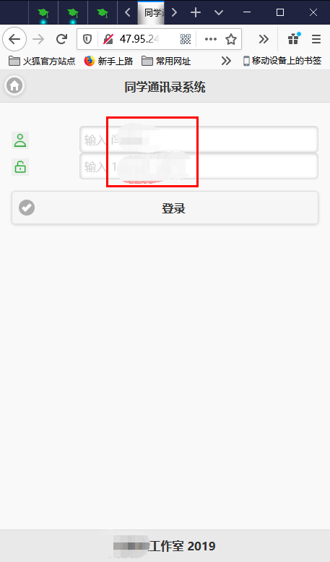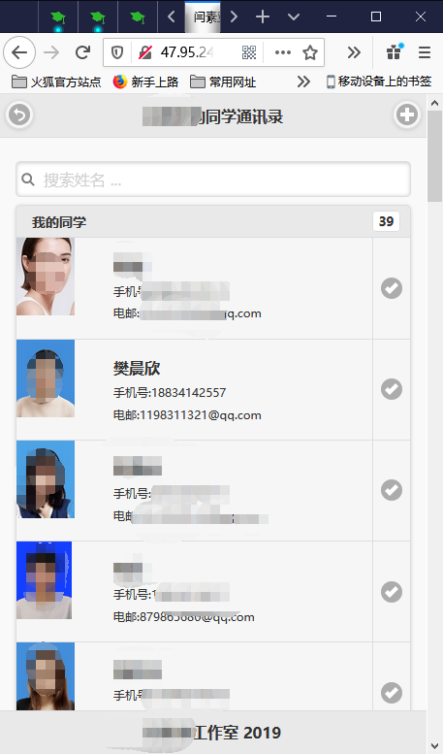
图4 登录页面(page0) 图5 浏览页面(page1)

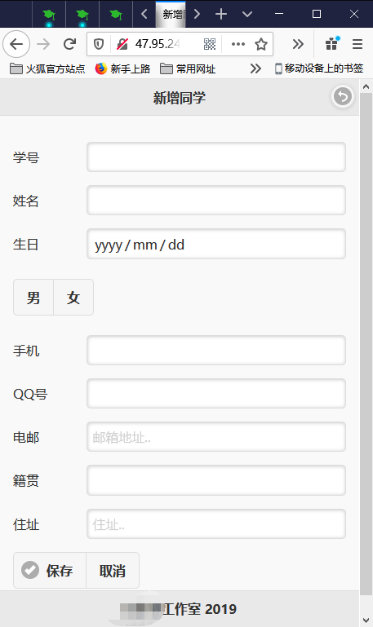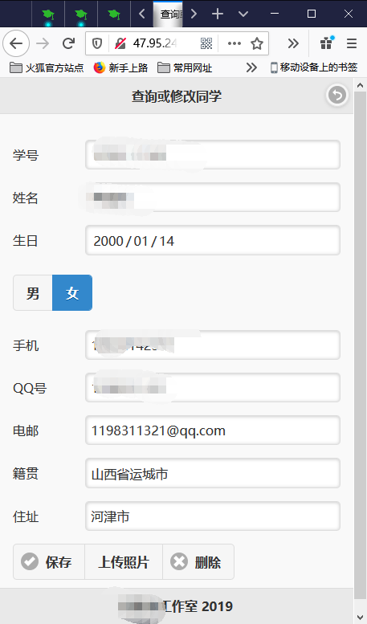
图6 新增同学页面(page2) 图7 查询、修改页面(page4)

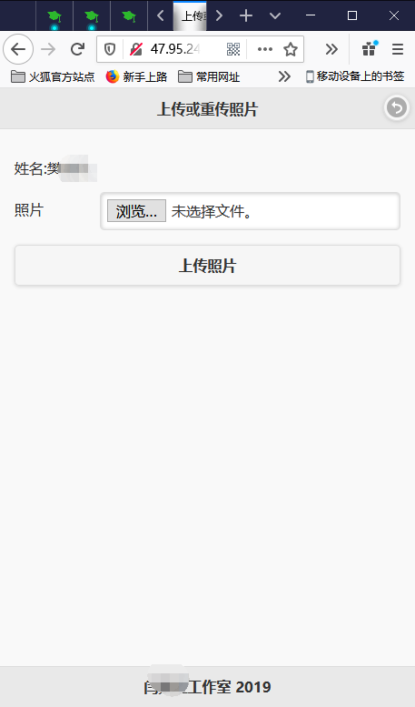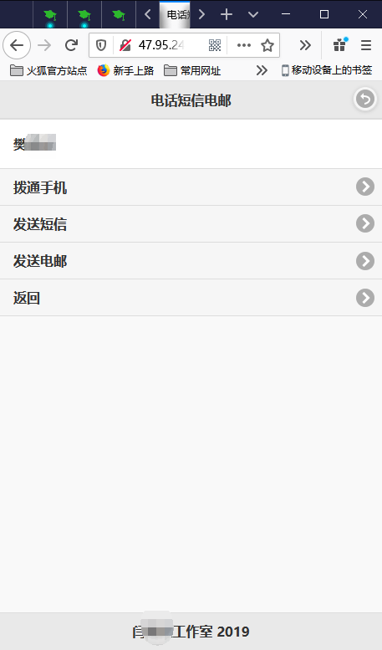
图8 上传照片页面(setpic_page) 图9 电话短信电邮拨打界面(page3)

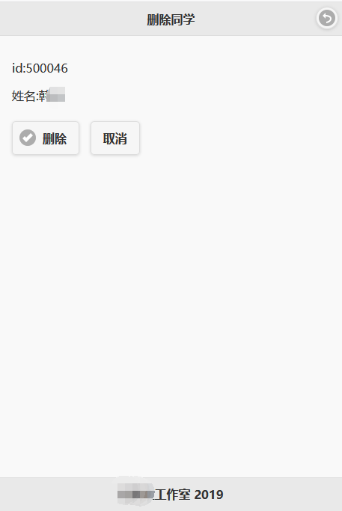
图10 删除同学界面(del_page)
移动端前端页面，在/php/jqmpdo/index.html。

<!DOCTYPE html>
<html>
<head>
<title>XXX的同学通讯录</title>
<meta charset="utf-8"/>
<meta name="viewport" content="width=device-width, initial-scale=1"/>
<meta name="apple-mobile-web-app-capable" content="yes">
<meta name="apple-touch-fullscreen" content="yes">
<meta name="apple-mobile-web-app-status-bar-style" content="black">
<meta name="format-detection" content="telephone=yes">

<link rel="stylesheet" href="js/jquery.mobile-1.4.5.min.css"/>
<script src="js/jquery-1.11.3.min.js"></script>
<script src="js/jquery.mobile-1.4.5.min.js"></script>
<script src="js/md5.js"></script>
<script charset="utf-8">
$(function(){
$(document).on("pageinit","#page1",function(){
//$('#page1').on('pageshow', function(event, ui){
$.ajax("getStuAll_xxx.php",{
type:'get',
success:function(data1){
//1、数据
var data = JSON.parse(data1);
/*2、修改模板用户数据和计数*/
var viewObj=$("#user_view");
$("#user_count",viewObj).html(data.length);
for(var key in data[0]){
$("[dbField='"+key+"']",viewObj).html(data[0][key]);
}
$("[dbField='照片']",viewObj).attr('src', 'getPhoto_xxx.php?id='+data[0]['id']);
$("[dbField='通信']",viewObj).attr('href', '?手机号='+data[0]['手机号']+'&姓名='+data[0]['姓名']+'&电邮='+data[0]['EMail']+'#page3');
$("[dbField='修改']",viewObj).attr('href', '?id='+data[0]['id']+'#page4');
/*3、循环遍历数据，并克隆模板，将数据插入到模板dbField相对应的节点中，然后增加到listview上*/
for(var i=1; i<data.length; i++){
var liTplObj=$("#li_tpl").clone();
for(var key in data[i]){
$("[dbField='"+key+"']",liTplObj).html(data[i][key]);
}
//console.log('/getPhoto_xxx.php?id='+data[i]['id']);
$("[dbField='照片']",liTplObj).attr('src', 'getPhoto_xxx.php?id='+data[i]['id']);
$("[dbField='通信']",liTplObj).attr('href', '?手机号='+data[i]['手机号']+'&姓名='+data[i]['姓名']+'&电邮='+data[i]['EMail']+'#page3');
$("[dbField='修改']",liTplObj).attr('href', '?id='+data[i]['id']+'#page4');
viewObj.append(liTplObj);
}
//4、刷新 以上二种都可以刷新数据
viewObj.listview("refresh");
//viewObj.selectmenu("refresh",true); _xxx
}
});
});
$(document).on("pageinit","#page3",function(){
var Obj = $("#通信");
$("[dbField='姓名']",Obj).html(getParameterByName('姓名'));
$("[dbField='手机1']",Obj).attr('href', 'tel:'+getParameterByName('手机号'));
$("[dbField='手机2']",Obj).attr('href', 'sms:'+getParameterByName('手机号')+'?body=短信内容');
$("[dbField='电邮']",Obj).attr('href', 'mailto:'+getParameterByName('EMail')+'?subject=您好');
});
$(document).on("pageinit","#page4",function(){
$("#e_id").html(getParameterByName('id'));
$.ajax("getStuById_xxx.php?id="+getParameterByName('id'),{
type:'get',
success:function(data1){
//1、数据
var data = JSON.parse(data1);
/*2、修改模板*/
var viewObj=$("#e_form");
for(var key in data[0]){
$("[dbField='"+key+"']",viewObj).val(data[0][key]);
}
if(data[0]['性别']=='男')
$("#emale").attr('checked', true).checkboxradio('refresh');
else
$("#efamale").attr('checked',true).checkboxradio('refresh');
console.log(data[0]['id']);
console.log(data[0]['姓名']);
$("#d_id").html(data[0]['id']);
$("#d_name").html(data[0]['姓名']);
$("#u_name").html(data[0]['姓名']);
$("#u_id").val(data[0]['id']);
}
});
});
});
//登录按钮
$(document).on("vclick","#b_login",function(){
$.ajax("login_xxx.php",{
type:'post',
data:{"用户名":$("#用户名").val(),"密码":hex_md5($("#密码").val())},
success:function(data1){
var data = JSON.parse(data1);
if (data.success == true)
$.mobile.changePage("#page1");
else
alert("用户名或密码错误！");
// $.messager.show({
// title: 'Error',
// msg: "用户名或密码错误！"
// });
}
});
});
//添加同学—添加按钮
$(document).on("vclick","#btn_add",function(){
$.ajax("addStu_xxx.php",{
type:'post',
data:{"学号":$("#A学号").val(),"姓名":$("#A姓名").val(),"性别":$("#amale").attr('checked')?'男':'女',"生日":$("#A生日").val(),
"手机号":$("#A手机").val(),"QQ号":$("#AQQ").val(),"EMail":$("#Aemail").val(),"籍贯":$("#A籍贯").val(),"住址":$("#A住址").val(),"班级id":$("#A班级id").val()},
success:function(data1){
var data = JSON.parse(data1);
if (data.success == true)
$.mobile.changePage("#page1",{reloadPage:false});
}
});
});
//修改同学—保存按钮
$(document).on("vclick","#btn_save",function(){
$.ajax("saveStu_xxx.php",{
type:'post',
data:{"id":$("#Eid").val(),"学号":$("#E学号").val(),"姓名":$("#E姓名").val(),"性别":$("#emale").attr('checked')?'男':'女',"生日":$("#E生日").val(),
"手机号":$("#E手机").val(),"QQ号":$("#EQQ").val(),"EMail":$("#Eemail").val(),"籍贯":$("#E籍贯").val(),"住址":$("#E住址").val()},
success:function(data1){
var data = JSON.parse(data1);
if (data.success == true)
$.mobile.changePage("#page1");
}
});
});
//删除同学—删除按钮
$(document).on("vclick","#btn_del",function(){
$.ajax("delStu_xxx.php?id="+$("#d_id").html(),{
type:'get',
success:function(data1){
var data = JSON.parse(data1);
if (data.success == true)
$.mobile.changePage("#page1");
}
});
});
//修改同学—上传照片按钮
$(document).on("vclick","#btn_upphoto",function(){
var formdata = new FormData($("#u_form"));
$.ajax("setPhoto_xxx.php",{
type:'post',
data:formdata,
success:function(data1){
var data = JSON.parse(data1);
if (data.success == true)
$.mobile.changePage("#page4");
}
});
});
// 获取get参数
function getParameterByName(name){
m = new RegExp('[?&]' + name + '=([^&]*)').exec(decodeURIComponent(window.location.search));
return m && decodeURIComponent(m[1].replace(/\+/g, ' '));
}
function handleFiles(files){
if(files.length){
let file = files[0];
let reader = new FileReader();
reader.onload = function(){
$('#prephoto').attr('src',this.result);
};
reader.readAsDataURL(file);
}
}
var photo;
</script>
</head>
<body>
<div data-role="page" id="page0">
<div data-role="header" data-position="fixed">
<a href="/index.html" data-role="button" data-icon="home" data-iconpos="notext">首页</a>
<h1>XXX同学通讯录系统</h1>
</div>
<div data-role="content">
<form id="f_login">
<div data-role="fieldcontain">
<label for="username"><img src="image/user.png"></label>
<input type="text" id="用户名" placeholder="输入 XXX" required>
<label for="pwd"><img src="image/pwd.png"></label>
<input type="password" id="密码" placeholder="输入 18" required>
</div>
<a id="b_login" data-role="button" data-icon="check" >登录</a>
</form>
</div>
<div data-role="footer" data-position="fixed">
<h1>XXX工作室 2019</h1>
</div>
</div>

<div data-role="page" id="page1">
<div data-role="header" data-position="fixed">
<a href="#page0" data-icon="back" data-role="button" data-iconpos="notext" >返回</a>
<h1>XXX的同学通讯录</h1>
<a href="#page2" data-role="button" data-icon="plus" data-iconpos="notext" class="ui-btn-right" title="添加同学">添加同学</a>
</div>
<div data-role="content">
<ul data-role='listview' id="user_view" data-inset="true" data-filter="true" data-filter-placeholder="搜索姓名 ...">
<li data-role="list-divider">我的同学<span class="ui-li-count" id="user_count"></span></li>
<li id="li_tpl" data-icon="check">
<a dbField='通信' title="拨打电话、发短信、发电子邮件" rel="external">
<img dbField='照片' height='80px'>
<h1 dbField='姓名'></h1>
<p>手机号:<span dbField='手机号'></span></p>
<p>电邮:<span dbField='EMail'></span></p>
</a>
<a dbField='修改' data-transition="pop" rel="external">查看同学详细信息或修改同学信息</a>
</li>
</ul>
</div>
<div data-role="footer" data-position="fixed">
<h1>XXX工作室 2019</h1>
</div>
</div>

<div data-role="page" id="page2">
<div data-role="header" data-position="fixed">
<h1>新增同学</h1>
<a href="#page1" data-role="button" data-icon="back" data-iconpos="notext" class="ui-btn-right">返回</a>
</div>
<div data-role="content">
<form method="post" id="a_form">
<div data-role="fieldcontain">
<label for="学号">学号</label>
<input type="text" id="A学号" required>
</div>
<div data-role="fieldcontain">
<label for="姓名">姓名</label>
<input type="text" id="A姓名" required>
</div>
<div data-role="fieldcontain">
<label for="班级id">班级id</label>
<input type="date" id="A班级id" required>
</div>
<div data-role="fieldcontain">
<label for="生日">生日</label>
<input type="date" id="A生日" required>
</div>
<fieldset data-role="controlgroup" data-type="horizontal">
<label for="amale">男</label>
<input type="radio" name="A性别" id="amale" value="男" data-inline="true">
<label for="afamale">女</label>
<input type="radio" name="A性别" id="afamale" value="女" data-inline="true">
</fieldset>
<div data-role="fieldcontain">
<label for="手机">手机</label>
<input type="text" id="A手机" required>
</div>
<div data-role="fieldcontain">
<label for="QQ">QQ号</label>
<input type="text" id="AQQ" required>
</div>
<div data-role="fieldcontain">
<label for="email">电邮</label>
<input type="email" id="Aemail" placeholder="邮箱地址.." required>
</div>
<div data-role="fieldcontain">
<label for="籍贯">籍贯</label>
<input type="text" id="A籍贯" required>
</div>
<div data-role="fieldcontain">
<label for="住址">住址</label>
<input type="text" id="A住址" placeholder="住址..">
</div>
</form>

<div data-role="controlgroup" data-type="horizontal">
<a href="#page1" id="btn_add" data-role="button" data-icon="check" data-inline="true" >保存</a>
<a href="#" data-role="button" data-rel="back" data-inline="true">取消</a>
</div>
</div>
<div data-role="footer" data-position="fixed">
<h1>XXX工作室 2019</h1>
</div>
</div>

<div data-role="page" id="page3">
<div data-role="header" data-position="fixed">
<h1>电话短信电邮</h1>
<a data-role="button" data-icon="back" data-iconpos="notext" href="#page1" class="ui-btn-right">返回</a>
</div>
<div data-role="content">
<ul data-role="listview" id='通信'>
<li><h2 dbField='姓名'></h2></li>
<li><a href="#" data-ajax="false" dbField='手机1'>拨通手机</a></li>
<li><a href="#" data-ajax="false" dbField='手机2'>发送短信</a></li>
<li><a href="#" data-ajax="false" dbField='电邮'>发送电邮</a></li>
<li><a href="#page1" data-icon="back" >返回</a></li>
</ul>
</div>
<div data-role="footer" data-position="fixed">
<h1>XXX工作室 2019</h1>
</div>
</div>

<div data-role="page" id="page4">
<div data-role="header" data-position="fixed">
<h1>查询或修改同学</h1>
<a data-role="button" data-icon="back" data-iconpos="notext" href="#page1" class="ui-btn-right">返回</a>
</div>
<div data-role="content">
<form method="post" id="e_form">
<input dbField='id' type="hidden" id="Eid">
<div data-role="fieldcontain">
<label for="学号">学号</label>
<input dbField='学号' type="text" id="E学号" required>
</div>
<div data-role="fieldcontain">
<label for="姓名">姓名</label>
<input dbField='姓名' type="text" id="E姓名" required>
</div>
<div data-role="fieldcontain">
<label for="生日">生日</label>
<input dbField='生日' type="date" id="E生日" required>
</div>
<fieldset data-role="controlgroup" data-type="horizontal">
<label for="emale">男</label>
<input type="radio" name="E性别" id="emale" value="男" data-inline="true">
<label for="efamale">女</label>
<input type="radio" name="E性别" id="efamale" value="女" data-inline="true">
</fieldset>
<div data-role="fieldcontain">
<label for="手机">手机</label>
<input dbField='手机号' type="text" id="E手机" required>
</div>
<div data-role="fieldcontain">
<label for="QQ">QQ号</label>
<input dbField='QQ号' type="text" id="EQQ" required>
</div>
<div data-role="fieldcontain">
<label for="email">电邮</label>
<input dbField='EMail' type="email" id="Eemail" placeholder="邮箱地址.." required>
</div>
<div data-role="fieldcontain">
<label for="籍贯">籍贯</label>
<input dbField='籍贯' type="text" id="E籍贯" required>
</div>
<div data-role="fieldcontain">
<label for="住址">住址</label>
<input dbField='住址' type="text" id="E住址" placeholder="住址..">
</div>
</form>

<div data-role="controlgroup" data-type="horizontal">
<a id="btn_save" data-role="button" data-icon="check" data-inline="true" >保存</a>
<a href="#setpic_page" data-role="button" data-inline="true" >上传照片</a>
<a href="#del_page" data-role="button" data-icon="delete" data-inline="true">删除</a>
</div>
</div>
<div data-role="footer" data-position="fixed">
<h1>XXX工作室 2019</h1>
</div>
</div>

<div data-role="page" id="del_page">
<div data-role="header" data-position="fixed">
<h1>删除同学</h1>
<a data-role="button" data-icon="back" data-iconpos="notext" href="#page1" class="ui-btn-right">返回</a>
</div>
<div data-role="content">
<p>id:<span id="d_id">。。</span></p>
<p>姓名:<span id="d_name">。。</span></p>
<a id="btn_del" data-role="button" data-icon="check" data-inline="true" >删除</a>
<a href="#" data-role="button" data-rel="back" data-inline="true">取消</a>
</div>
<div data-role="footer" data-position="fixed">
<h1>XXX工作室 2019</h1>
</div>
</div>

<div data-role="page" id="setpic_page">
<div data-role="header" data-position="fixed">
<h1>上传或重传照片</h1>
<a data-role="button" data-icon="back" data-iconpos="notext" data-rel="back" class="ui-btn-right">返回</a>
</div>
<div data-role="content">
<form id="u_form" enctype="multipart/form-data" method="post" data-ajax="false" action="setPhoto_xxx.php">
<input type="hidden" id="u_id" name="id">
<p>姓名:<span id="u_name">。。</span></p>
<div data-role="fieldcontain">
<label for="照片">照片</label>
<input type="file" name="photo" required onchange="handleFiles(this.files)" accept="image/x-png,image/gif,image/jpeg,image/bmp" >
</div>
<input data-role="button" type="submit" value="上传照片">
</form>
<img id="prephoto" height='80px'>
</div>
<div data-role="footer" data-position="fixed">
<h1>XXX工作室 2019</h1>
</div>
</div>
</body>
</html>

3.3 Web服务器后端程序
下列9个php文件位置/php/jqmpdo/
(1) 数据库连接conn_xxx.php
<?php
header("content-type:text/html;charset=utf-8");
//header("Access-Contro$resAllow-Origin: *");
//header("Access-Control-Allow-Headers: Origin, X-Requested-With, Content-Type, Accept");
$dsn="mysql:dbname=XXX的数据库;host=47.95.241.177;port=3306;charset=utf8";
$db_user='用户名';
$db_pass='密码';
//$opt = array(PDO::MYSQL_ATTR_INIT_COMMAND=>'set names utf8');
try{
$pdo = new PDO($dsn,$db_user,$db_pass);//,$opt);
}catch(PDOException $e){
die("数据库连接失败!!!".$e->getMessage()."<br>");
}
?>

(2) 登录校验 login_xxx.php
<?php
$username = $_POST['用户名'];
$pwd = $_POST['密码'];
$mm = md5($username.$pwd);
include 'conn_xxx.php';

$sql = "select 用户名 from 用户表_ysy where (用户名 = '$username' and 密码 = '$mm' );";

$res = $pdo->query($sql);
$num_rows = $res->rowCount();

if ($num_rows==1){
echo json_encode(array('success'=>true));
} else {
echo json_encode(array('msg'=>'出现一些错误。'), JSON_UNESCAPED_UNICODE);
}
?>

(3) 获取所有同学信息 getStuAll_xxx.php
<?php
include "conn_xxx.php";
$sql= "SELECT id,学号,姓名,性别,生日,手机号,QQ号,EMail,籍贯,住址 FROM 同学表_xxx ";
$stmt = $pdo->prepare($sql);
$stmt->execute();
$items = $stmt->fetchAll(PDO::FETCH_ASSOC);
echo json_encode($items, JSON_UNESCAPED_UNICODE);
$pdo = null;
?>

(4) 根据id获取同学信息 getStuById_xxx.php
<?php
$id = intval($_REQUEST['id']);
include "conn_xxx.php";
$sql= "SELECT id,学号,姓名,性别,生日,手机号,QQ号,EMail,籍贯,住址 FROM 同学表_xxx where id = $id";
$stmt = $pdo->prepare($sql);
$stmt->execute( );
$items = $stmt->fetchAll(PDO::FETCH_ASSOC);
echo json_encode($items, JSON_UNESCAPED_UNICODE);
$pdo = null;
?>

(5) 添加同学addStu_xxx.php
<?php
$xh = $_POST["学号"];
$xm = $_POST["姓名"];
$xb = $_POST["性别"];
$sr = $_POST["生日"];
$sj = $_POST["手机号"];
$qq = $_POST["QQ号"];
$dy = $_POST["EMail"];
$jg = $_POST["籍贯"];
$zz = $_POST["住址"];
$bj = $_POST["班级id"];
include 'conn_xxx.php';
$sql = "insert into 同学表_xxx(学号, 姓名,性别, 生日, 手机号, QQ号, EMail, 籍贯, 住址, 班级id) values ('$xh', '$xm', '$xb', '$sr', '$sj', '$qq', '$dy', '$jg', '$zz', '$bj') ";
$res=$pdo->exec($sql);
if ($res ==1){
echo json_encode(array('success'=>true));
} else {
echo json_encode(array('msg'=>'出现一些错误。'), JSON_UNESCAPED_UNICODE);
}
$pdo = null;
?>

(6) 修改保存同学saveStu_xxx.php
<?php
$id = $_POST["id"];
$xh = $_POST["学号"];
$xm = $_POST["姓名"];
$xb = $_POST["性别"];
$sr = $_POST["生日"];
$sj = $_POST["手机号"];
$qq = $_POST["QQ号"];
$dy = $_POST["EMail"];
$jg = $_POST["籍贯"];
$zz = $_POST["住址"];
$class = $_POST["班级id"];
include 'conn_xxx.php';
$sql = "update 同学表_xxx set 学号 = '$xh', 姓名 = '$xm', 性别 = '$xb', 生日 = '$sr', 手机号 = '$sj', QQ号 = '$qq', EMail = '$dy', 籍贯 = '$jg', 住址 = '$zz', 班级id = '$class' where id = $id";
$res=$pdo->exec($sql);
if ($res ==1){
echo json_encode(array('success'=>true));
} else {
echo json_encode(array('msg'=>'出现一些错误。'), JSON_UNESCAPED_UNICODE);
}
$pdo = null;
?>

(7) 删除同学delStu_xxx.php
<?php
$id = intval($_REQUEST['id']);
include 'conn_xxx.php';
$sql = "delete from 同学表_xxx where id = $id";
$res=$pdo->exec($sql);
if ($res==1){
echo json_encode(array('success'=>true));
} else {
echo json_encode(array('msg'=>'出现一些错误。'), JSON_UNESCAPED_UNICODE);
}
$pdo = null;
?>

(8) 获取同学照片getPhoto_xxx.php
<?php
$id = isset($_GET['id']) ? $_GET['id'] : 500046;
include "conn_xxx.php";
$sql = "select 照片, 照片类型 from 同学表_xxx where id = :id;";
$stmt = $pdo->prepare($sql); image/
$stmt->execute(array(":id" => $id));
$stmt->bindColumn(2, $ext);
$stmt->bindColumn(1, $data, PDO::PARAM_LOB);
$stmt->fetch(PDO::FETCH_BOUND);
header("Access-Control-Allow-Origin: *");
header("Access-Control-Allow-Headers: Origin, X-Requested-With, Content-Type, Accept");
header('Content-Type:image/'.$ext);
echo $data;
$pdo = null;
?>

(9) 上传保存同学照片setPhoto_xxx.php
<?php
// 连接数据库
include "conn_xxx.php";
$id = $_REQUEST['id'];
$fp = fopen($_FILES['photo']['tmp_name'], 'rb');
$file_name = $_FILES['photo']['name'];//获取缓存区图片,格式不能变
$ext = explode(".", $file_name);//拆分获取图片名
$ext = $ext[count($ext) - 1];//取图片的后缀名
$stmt = $pdo->prepare("update 同学表_xxx set 照片 = ?, 照片类型 = ? where id = ?");
$stmt->bindParam(1, $fp, PDO::PARAM_LOB); //图片二进制数据
$stmt->bindParam(2, $ext); //图片类型
$stmt->bindParam(3, $id);
$pdo->beginTransaction();
$stmt->execute();
$res=$pdo->commit();
header("Access-Control-Allow-Origin: *");
header("Access-Control-Allow-Headers: Origin, X-Requested-With, Content-Type, Accept");
header("content-Type: text/html; charset=utf-8");
if ($res==1){
//echo json_encode(array('success'=>true));
echo header('Location:index.html#page1');
exit;
} else {
echo json_encode(array('msg'=>'出现一些错误。'), JSON_UNESCAPED_UNICODE);
}
$pdo = null;
?>
4. 实训小结
写上5-9行知识点小结、收获体会

